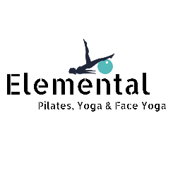
ONLINE CLASS SCHEDULE
MONDAY  Face Yoga - 9:30  Yoga – 10:00  Pilates – 17:15 | TUESDAY  Face Yoga – 9:30  Pilates w/ Foam  Roller – 10:00 | WEDNESDAY  Face Yoga – 9:30  Yoga – 10:00  Pilates – 18:30
THURSDAY  Pilates – recording available | FRIDAY  Meditation – 9:00  Pilates – 9:30 | SUBSCRIPTIONS:  Pilates - £15 two weeks.  Yoga - £10 two weeks.  Face Yoga - £10 two weeks.  All Pilates classes are 45 mins.  Yoga and Face Yoga require a separate subscription.
PILATES – Matwork Pilates class combining strengthening, mobilisation and stretch techniques to work the whole body, suitable for most levels. We will use a stretch band, small ball and sometime a foam roller to deepen the work, but if you don’t have them, an alternative modification will be given.

FoamRoller – we will be needing a foam roller for this class working on hydrating the fascia in the body, performing a specific set of movements to release tension and promote better movement through the connective tissue.

Face Yoga – Relaxing yet effective routine of face exercises and face massage to keep us glowing, healthy and younger looking. No tools required, although a mirror is advisable. Just bring your beautiful faces, with or without make up, and of course a smile! Suitable for all levels.

Yoga – a fusion of classic yoga asanas and Pilates core work, this class combines the best of both worlds – teaching you how to find your abdominal muscles before taking you on a journey through yoga asanas, designed at opening the shoulders and chest, increasing flexibility in the hamstrings and hips and strengthening the low back. Suitable for all levels including beginners.

Yoga Meditation – a 20 mins class focusing on finding the stillness in the mind. Includes asana warm up before a seated meditation. The style varies weekly and includes breathwork, mantras and visualisation.

